FOOD MANAGEMENT SYSTEM

**Use-Case Specification: Cancel selected product**

Version <1.0>

Revision History

|  |  |  |  |
| --- | --- | --- | --- |
| **Date** | **Version** | **Description** | **Author** |
| <7/12/2020> | <1.0> | <details> | <Nguyen Thu Trang> |

Table of Contents

1. Use-Case Name 4

1.1 Brief Description 4

2. Flow of Events 4

2.1 Basic flow 4

2.2 Alternative flow 4

2.2.1 <First Alternative flow> 4

2.2.1 <Second Alternative flow> 4

3. Special Requirement 4

3.1 <First Special Requirement> 4

4. Preconditions 4

4.1 <Precondition One> 4

5. Posstcondition 4

5.1 <Postcondition One> 4

6. Extension Points 4

6.1 < Name of Extension Points> 5

**Use-Case Specification: Cancel selected product**

1. **Cancel selected product**
   1. **Brief Description**

This use case defines the step of Cancel selected product. Customers cancel selected product that they have order

* 1. **Actor**

Customer

1. **Flow of Events**
   1. **Basic Flow**

First, customer click on manage product button. The system display product selected view. Customer will click "cancel” next to the product need to cancel. Customer click on Save to confirm change. After, system will update product information

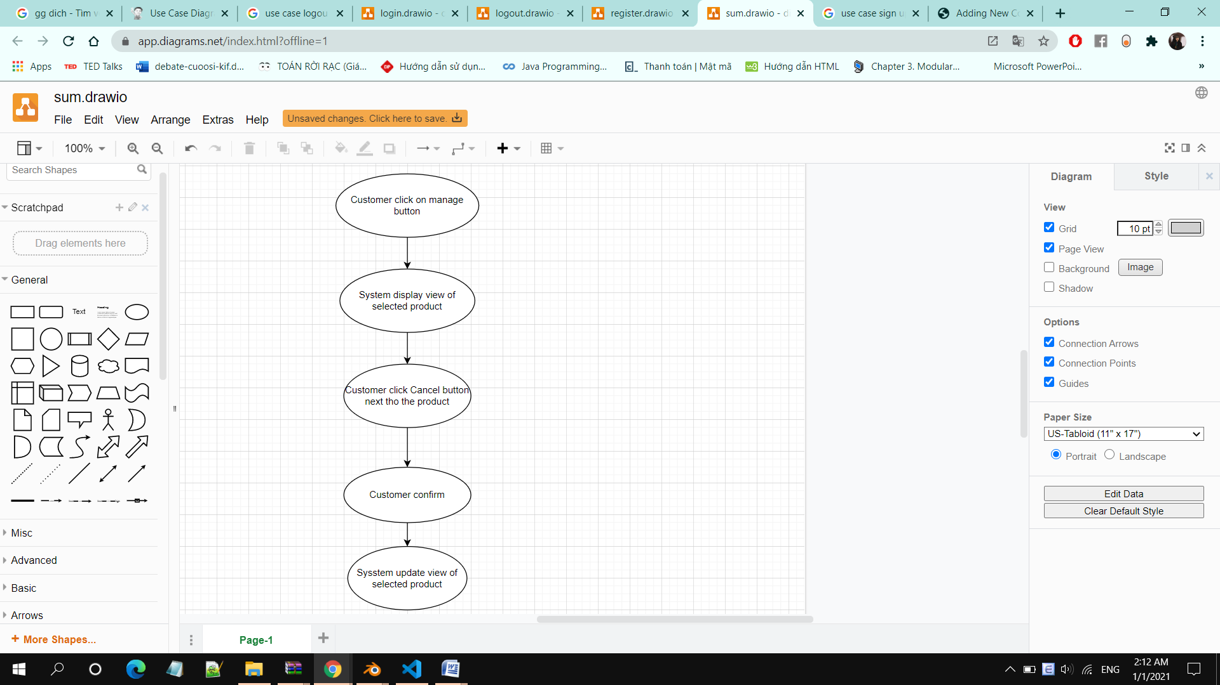

1. **Special Requirements**

None

1. **Preconditions**

Customers have ordered successfully and viewed order status

1. **Postconditions**

Canceled order

1. **Extension Points**

No extension points.